Here are the key **limitations** of an **array** compared to a **linked list**:

**1. Fixed Size:**

* **Array**: The size of an array is fixed at the time of its creation. Once an array is defined, its size cannot be changed without creating a new array and copying the elements over.
* **Linked List**: A linked list is dynamic in size. You can easily add or remove elements without worrying about pre-defining the size.

**2. Memory Allocation:**

* **Array**: Arrays require a contiguous block of memory. If the system cannot allocate enough contiguous memory space, it might lead to memory allocation failure.
* **Linked List**: Linked lists use non-contiguous memory blocks. Each element (node) is allocated memory dynamically, making them more flexible in utilizing memory.

**3. Insertion/Deletion:**

* **Array**: Inserting or deleting an element in an array (especially in the middle) can be costly. After an insertion or deletion, elements after the position need to be shifted to accommodate the new or removed element. This can take **O(n)** time.
* **Linked List**: Insertion or deletion in a linked list (especially at the beginning or in the middle) can be done in **O(1)**time, as it only requires changing pointers. However, finding the position still takes **O(n)** time in an unsorted list.

**4. Accessing Elements:**

* **Array**: Arrays provide **constant-time** access (O(1)) to elements by index, as elements are stored in contiguous memory locations.
* **Linked List**: To access an element in a linked list, you need to traverse from the head node, which can take **O(n)**time in the worst case.

**5. Memory Overhead:**

* **Array**: Arrays have **no extra memory overhead** other than the memory used for the elements themselves.
* **Linked List**: Each node in a linked list requires extra memory for the pointer/reference (to link to the next node), which increases memory overhead.

**6. Resizing:**

* **Array**: If an array is full and you want to add more elements, you must create a new array with a larger size and copy all elements from the old array to the new one. This resizing operation can be time-consuming.
* **Linked List**: Linked lists can grow or shrink easily by adding or removing nodes without needing resizing or shifting elements.

**7. Cache Locality:**

* **Array**: Arrays benefit from **better cache locality** because elements are stored contiguously in memory. This can result in better performance due to the way modern CPUs cache memory.
* **Linked List**: Linked lists can have **poor cache locality** because elements are scattered throughout memory, leading to slower access times in some cases.

**8. Random Access:**

* **Array**: Arrays allow **random access** to any element using an index, making them efficient for situations where frequent access to arbitrary elements is required.
* **Linked List**: Linked lists do not allow **random access**; to access an element, you need to traverse from the head, which can be slower.

**9. Memory Fragmentation:**

* **Array**: Arrays require a large contiguous block of memory, which might not always be available, especially in systems with fragmented memory.
* **Linked List**: Linked lists can handle fragmented memory more efficiently because nodes are stored in non-contiguous memory locations.

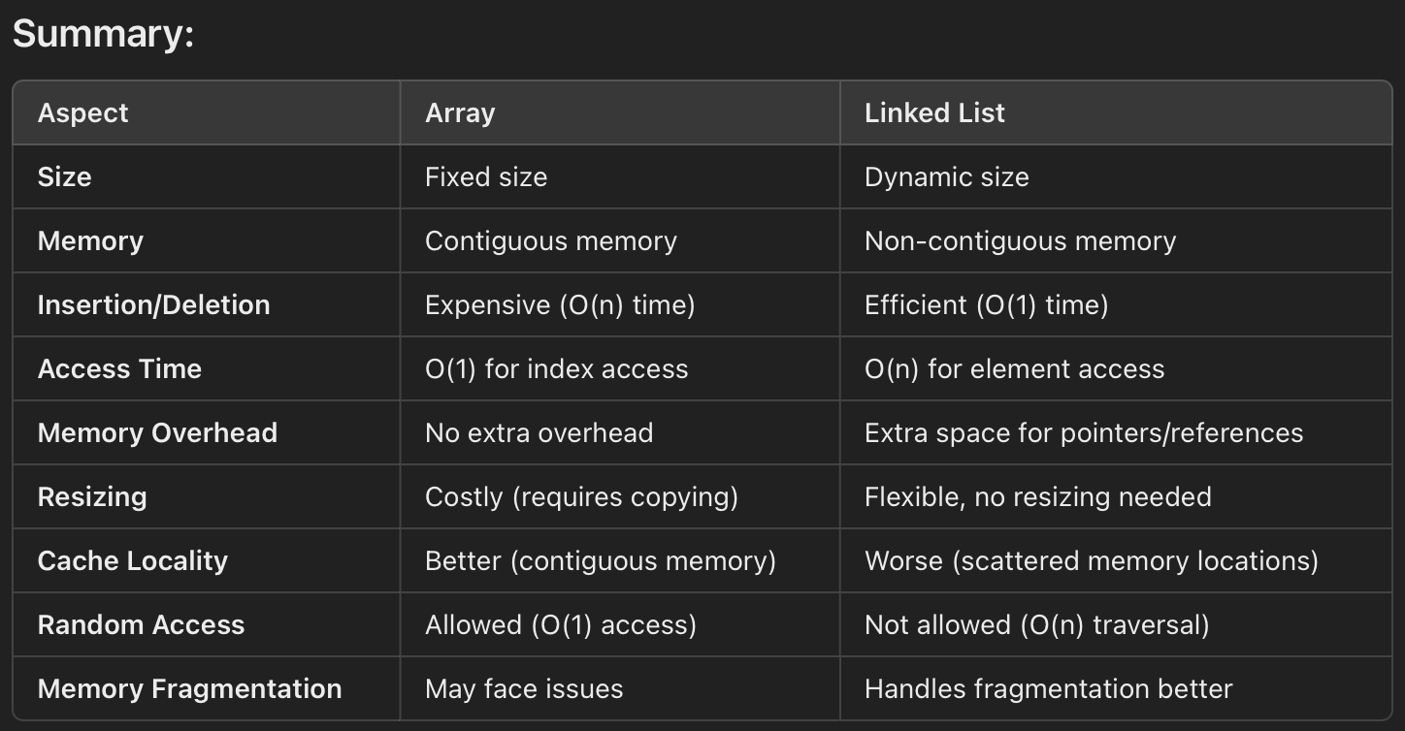

Here are the **advantages** and **disadvantages** of using a **linked list**:

**Advantages of Linked List:**

1. **Dynamic Size**:
   * Linked lists do not require a predefined size. They can grow or shrink dynamically, meaning you don’t need to know the number of elements ahead of time.
2. **Efficient Insertions and Deletions**:
   * Inserting or deleting elements (especially at the beginning or in the middle) is very efficient, taking constant time **O(1)**, as it only requires adjusting pointers.
   * There is no need to shift elements, unlike in an array, where insertion or deletion requires moving other elements.
3. **Memory Efficiency**:
   * Linked lists use memory dynamically, meaning they allocate memory as needed for each new node, without needing a contiguous block of memory.
   * This makes them more flexible in situations where the size of the list is uncertain or highly variable.
4. **No Wasted Space**:
   * Unlike arrays, which may have unused allocated space if the number of elements is less than the allocated size, linked lists use only the memory required for the nodes.
5. **Avoids Fixed Size Limitations**:
   * There’s no risk of "array overflow" as the list can grow indefinitely, as long as there is available memory.

**Disadvantages of Linked List:**

1. **Memory Overhead**:
   * Each element in a linked list (node) requires additional memory to store a pointer/reference to the next element, leading to higher memory usage compared to arrays.
   * For example, in a singly linked list, each node needs extra memory for the pointer to the next node.
2. **No Random Access**:
   * Linked lists do not support direct random access to elements. To access an element at a specific position, you must traverse the list from the head to that position, resulting in **O(n)** time complexity for access.
   * This is slower compared to arrays, where you can access any element in **O(1)** time using an index.
3. **Complexity in Implementation**:
   * Linked lists require more complex logic to manage memory and pointers, making them harder to implement and manage than arrays.
   * Handling edge cases (like insertion or deletion at the head, tail, or middle) requires more careful management.
4. **Slower Traversal**:
   * Accessing or searching for an element in a linked list requires traversal from the head node to the desired position, which can take time proportional to the number of elements, i.e., **O(n)**.
   * This is slower than array-based data structures for tasks like searching or iterating over elements.
5. **Cache Locality Issues**:
   * Linked lists have poor cache locality compared to arrays because nodes are often scattered throughout memory (non-contiguous). This can result in slower access times due to less efficient CPU cache utilization.
6. **Pointer Management**:
   * Managing pointers, especially in more complex linked list types (like doubly linked lists or circular linked lists), can be tricky and error-prone.
   * Improper pointer management can lead to issues like memory leaks or segmentation faults.

